Community Days of Action Toolkit
Urban Indian Health Institute

Table of Contents

One-page description of Community Days of Action 3
Flyer for Microsoft Word 4
Suggested Social Media Posts 5
Create Your Own Video 6
Media Advisory Template 7
Press Release Template 9

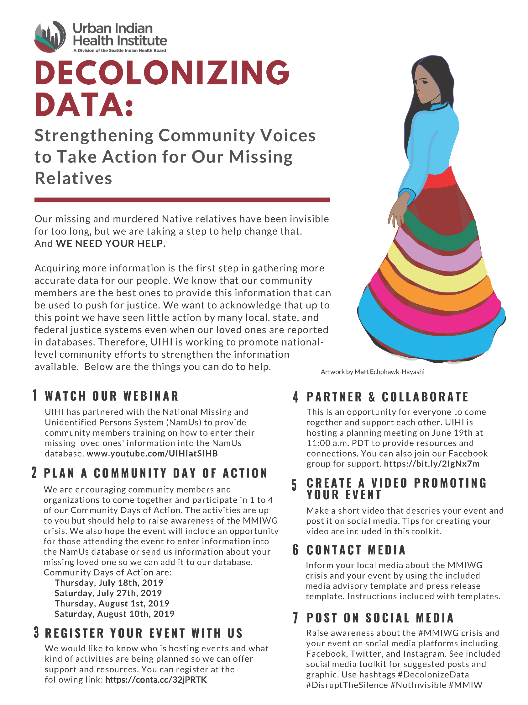

[Add your organization’s logo]

Community Day of Action

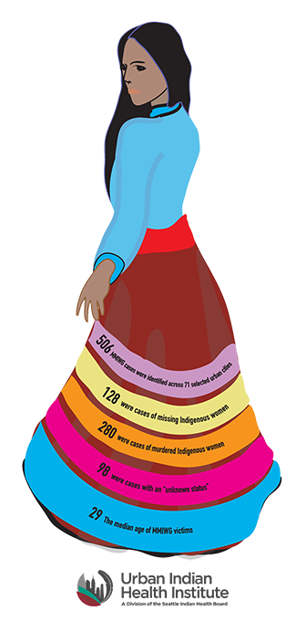

Artwork by Matt Echohawk-Hayashi

When:
Where:

Contact [ insert contact person’s information] to get more information and RSVP.

Please bring your laptop if you have one!

Join us as we work together to make sure our missing Native loved ones are no longer invisible in the data. We will be entering information on our missing relatives into the NamUs federal database on this national Day of Action. #MMIWG

Social Media Toolkit
Use the following posts to promote your Community Days of Action event with your community through your social media networks. Share the ribbon skirt graphic (can be copied and/or saved below) with your posts. You can also share the flyer included with this toolkit with your posts.

Facebook:
Our missing relatives have been ignored in the data, but we are taking a step to change that. On [date] at [time], we will be hosting a Community Days of Action event for all members of our community to come together to enter information about their missing Native loved ones into the National Missing and Unidentified Persons System (NamUs) database. Help us make sure our missing relatives’ names are known. Check out @UrbanIndianHealthInstitute for more information and to learn how to host your own event. #DecolonizeData #WhyWeWearRed #notinvisible #DisruptTheSilence #MMIWG
Twitter:
(Correct the date and time your event will be held. Keep this format, though, as the character count is correct.)
Help us ensure our missing relatives are no longer ignored in the data. On 7/27 at 1pm, we will be hosting a community event where we will come together to enter our missing Native loved ones’ info into NamUs. @TheUIHI #DecolonizeData #notinvisible #NativeTwitter #MMIWG

Instagram:
Help us make sure our missing relatives’ names are known. On [date] at [time], we will be hosting a Community Days of Action event for our community to come together and enter information about their missing Native loved ones into the NamUs database. Our missing relatives have been ignored in the data, but we are taking a step to change that. Check out @UrbanIndianHealthInstitute for more information and to learn how to host your own event. #DecolonizeData #WhyWeWearRed #NotInvisible #DisruptTheSilence #MMIWG

DIY Community Days of Action video
If you’d like to make your own video to promote your Community Days of Action event with your community, here are a few tips and some examples!
- Be as serious or as humorous as you’d like. We recognize humor as part of our resilience, so it’s okay to be funny and lighthearted.
- The video can easily be shot using a cell phone.
- Keep the video under one (1) minute.
- Give brief details about the event (when, where, time).
- Share the video with a text post that explains more about the event and/or links to a place where people can RSVP (see example text below).
  - Help us make sure our missing relatives’ names are known. Join us on [date] at [time] at [location] as we come together to enter our missing relatives’ information into NamUs’ federal missing and unidentified persons database. To RSVP, please [enter instructions for RSVP, whether it’s to email someone or a link to a registration form]. Let’s come together and #DisruptTheSilence. #DecolonizeData #MMIWG #NotInvisible
Example 1: Serious
https://www.facebook.com/UrbanIndianHealthInstitute/videos/352785978698441/
Example 2: Humorous
https://www.facebook.com/UrbanIndianHealthInstitute/videos/406307723549459/
Template for Media Advisory
News media has been key to bringing attention to the missing and murdered indigenous women & girls (MMIWG) crisis. In order to bring media attention in your area around your Community Days of Action event, you will need to coordinate with media through media releases (media advisory and press release) and coordinating and conducting interviews.
What is a media advisory?
A media advisory is used to inform reporters of an upcoming event. Think of it as a detailed invitation to reporters that is meant to encourage them to attend an event and write a story.
Best practice for distributing media advisory
- Create a media list of 5-10 relevant local and regional reporters who cover social justice, Native, or community issues.
- Get contact information for the local Associated Press (AP) reporter. If an AP reporter decides to publish an article, it has the potential of local and national coverage.
- Be objective and state the facts. Reporters are looking for facts and unbiased information to determine if their readers will find your event or cause interesting.
- Highlight the people and opportunities and show/tell the reporter it is worth their time to cover the story or show up to the event.
- Be available and responsive to media requests. Reporters are regular people, so if you make their lives easier by being responsive and helping them coordinate interviews, your chances of getting media coverage will increase.
Instructions for using this template
- Customize all highlighted sections with information specific to your event.
- Spell check and proofread for formatting, spelling, and punctuation.
- Copy and paste the content into the body of the email.
- If you are distributing to more than one reporter, put all of the emails in the “bcc” field for email recipients (leave the “to” field blank).
- Send the press release to reporter immediately after the event.

Click here to see an example of a successful media advisory.

*SEE TEMPLATE ON NEXT PAGE

For immediate release—[month day, year]
[add logo, if applicable]
MEDIA ADVISORY
Local Native community gathering to enter names of missing indigenous people into Department of Justice national database
[City, State]—[Organization name/tribe/individual] is hosting an event where the [area you are hosting event] community will gather to enter the names of missing indigenous loved ones into the Department of Justice’s National Missing and Unidentified Persons System (NamUs) database. In 2016, there were only 116 cases of missing indigenous women and girls in the NamUs database, but there were more than 5,700 cases reported. This community gathering is one of many in a nationwide effort to ensure more accurate data is available regarding missing indigenous people.
Where and when:
[Location]
[Address of event and include Google Maps address to location]
Who:
- [List names and titles of people attending the event and who are willing to speak to media]
# # #
Contact:
[Contact Name]
[Phone number]
[email]

Template for Press Release
News media has been key to bringing attention to the missing and murdered indigenous women & girls (MMIWG) crisis. In order to bring media attention in your area around your Community Days of Action event, you will need to coordinate with media through media releases (media advisory and press release) and coordinating and participating in interviews.
What is a press release?
A press release is used to inform reporters about a story or event. Reporters get multiple press releases daily and are looking for stories that would be interesting to their readers.
Tips and best practices:
- Create a media list of 5-10 relevant local and regional reporters who cover social justice, Native, or community issues.
- Get contact information for local Associated Press (AP) reporter. If an AP reporter decides to write and publish an article, it has the potential of reaching a larger number of readers not only locally, but nationally.
- Be objective and state the facts. Reporters are looking for interesting and informative press releases to help them write their articles.
- Use your quotes to say what the facts can’t. Quotes are best used to get a message across that might either be an opinion or stance on a topic. Quotes humanize a press release but remember to keep the informative information unbiased. Reporters will be looking for that and it will also make your quotes more powerful and appealing.
- Be available and responsive to media requests. Reporters are regular people, so if you make their lives easier by being responsive and helping them coordinate interviews, your chances of getting media coverage will increase.
Instructions for using this template:
- Customize all highlighted sections with information specific to your event.
- Edit the first and closing quotes to best fit your position or message.
- Do a spell check and proofread for formatting, spelling, and punctuation.
- Copy and paste the content into the body of the email.
- If you are distributing to more than one reporter, put all of the emails in the “bcc” field for email recipients (leave the “to” field blank).
- Send the press release to reporter immediately after the event.

Click here to see an example of a successful press release.
*SEE TEMPLATE ON NEXT PAGE

For immediate release—[month day, year]
[insert your logo, if available]
Local Native-led community group enters names of missing indigenous people into Department of Justice database
[City, State]– A Native-led community group in [area] gathered to enter information about missing Native individuals into a national database to bring visibility to missing loved ones and further attention to the missing and murdered indigenous women and girls (MMIWG) crisis.
Department of Justice’s National Missing and Unidentified Persons System (NamUs) is a database that houses missing and unidentified persons cases in an effort to improve access to this information to help solve these cases. Information about the majority of missing indigenous peoples’ cases is absent from this database for many reasons including racial misclassification, mistrust with federal databases and law enforcement, capacity issues with law enforcement, and a general lack of knowledge around NamUs and the fact that the public can enter information themselves.
“Acquiring more information is the first step in gathering more accurate data for our people,” said [name, tribal affiliation (if applicable), title]. “We know that Native communities have the knowledge to make change happen, so we are taking the first steps in making sure our missing relatives’ names are known.”
The gathering is one of a number being conducted by Native-led community groups and organizations throughout the country to ensure better data exists around missing Native people in the NamUs database.
The campaign to enter data into NamUs is called Community Days of Action and started with a training with more than 600 people from tribes, Native organizations, and community organizers on how to enter information into the NamUs database. The training was conducted by Urban Indian Health Institute (UIHI) in partnership with NamUs.
“The need for these Community Days of Action comes from the fact that our missing relatives are going unnoticed and need to be known,” said Abigail Echo-Hawk, Director of Urban Indian Health Institute. “In our research, we found that there were only 116 cases of missing Native women and girls in NamUs, but that over 5,700 cases had been reported. That’s simply unacceptable and needs to change.”
UIHI is a Native nonprofit and Tribal Epidemiology Center located in Seattle, Wash. and released a report titled Missing and Murdered Indigenous Women & Girls in November of 2018. The report provided a snapshot of data on the MMIWG crisis in 71 cities across 29 states in the U.S. and highlighted issues around gathering data for MMIWG cases.
“We will continue to look for ways to honor our missing loved ones and bring attention to the issues that have led to the invisibility of Native people across the country,” said [name, tribal affiliation (if applicable), title]. “We hope that others will join us.”
####
Contact
[name]
[Phone]
[Email]
[You can include additional information (link, short bio) about your organization here, if you’d like]

